## Web Project – Design

##### Your Name: Aizada Azirbayeva

##### Outline the Content of the Website

1. Home Page – Aiza’s Bakery
2. Shop Menu
3. Birthday Party Menu
4. Gallery
5. Reviews
6. Contact Us

Web Structure   
**Web structure is going to be random which will allow users to go to any page on the website.**

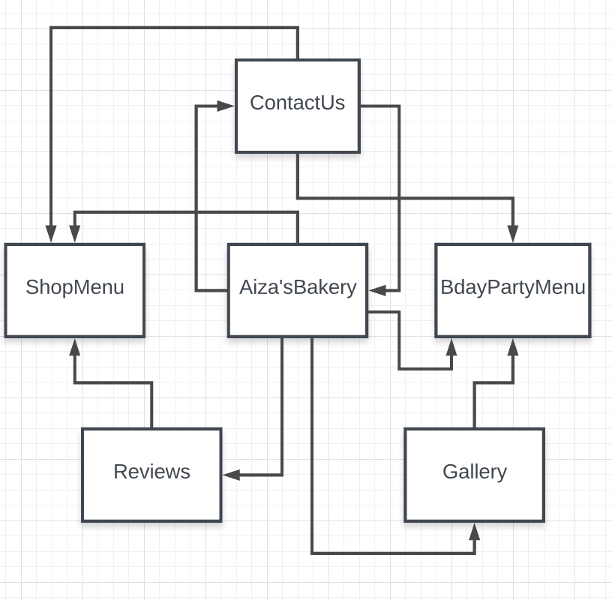

Logo

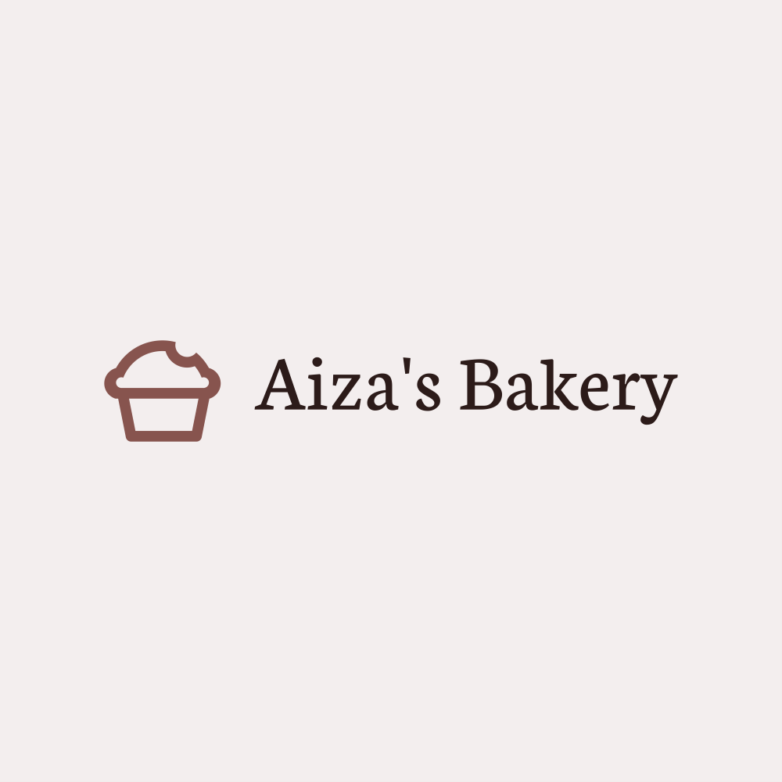 I decided to choose combination mark. As a logo I chose a cupcake with a modern look (looks like emoji), and font for the brand name (Aiza is my nick name) I chose plain typeface, I think it makes it look clean, friendly and a bit classy. I chose combination of light pink and chocolate brown colors, to have a feeling of a sweet light whip cream flavor with a pinch of a bitterness. Yummy.

Color Specifications   
Main color will be white, secondary color would be light pink # F3EEEE, text color would be in brown shades like #2C1B19, button color will be #EF7896 and text in the button will be white.

Graphics

Button are going to have a rectangle shape, and a border, and a transparent background. Images will have a card layout, also have image hover overlay with ingredients of bakery.

Typography

I will use Neuton Serif font which gives a classic feeling.

Page Layout

I used MockFlow Wireframe for creating my wireframe page layout. Though it was free, it had following limitations:

1. Could not add CSS
2. Could not draw flow for page transition
3. Could not export as a wireframe
4. Components like “footer” were missing.

I have attached Wireframe exported as an image in a zip, named AizaBakeryWireframe.zip

Zip has 2 pages design. 1st one is Home Page and second is Gallery Page.